Tab 1



Mtel (Thailand) Co., Ltd.

For

T.C.C. Technology Co., Ltd.

One Bangkok Mobile Application
Invitation Code & Upgrade Membership
Scope of work Document
To
T.C.C. Technology Co., Ltd.

Total 10 sheets (w/h cover sheet)
 | PROJECT NAME | JOB NO. | DOCUMENT NO. | REV.
 | One Bangkok Mobile Application - Invitation Code & Upgrade Membership Scope of work document |  |  | 01

Content table
1. Document Purpose 3
2. Project Background & Overview 4
2.1 Objectives 4
3. Scope 5
3.1 Frontend Development 5
3.2 Existing Features 5
3.2.1 Notification 5
3.2.2 Call Elevator 5
3.2.3 Visitor Access 5
3.2.4 Building Access - Request Services 5
3.2.5 Building Access - Air Conditioning Request 5
3.2.6 Parking 5
3.2.7 Security 5
3.2.8 Contact Directory 5
3.2.9 News & Announcement 6
3.2.10 What’s Happening 6
4. Acceptance Criteria 6
2. Deliverables 8
2.1. Functional Deliverables 8
2.2. Technical Deliverables 8
2.2.1. Backend APIs for: 8
2.3. Documentation Deliverables 9
2.4. Testing Deliverables 9

One Bangkok Mobile Application - Workplace features design revamp
To
T.C.C. Technology Co., Ltd.
This document serves as the official Scope of Work (SOW) and sign-off for Phase I of the One Bangkok Mobile Workplace Design Revamp, covering User Experience (UX/UI) design and Frontend development. The objective is to align Workplace features with the new design system and updated UX/UI, ensuring consistency with the One Bangkok application. This document defines the deliverables, including the Feature List for Phase I (30 September 2025), and covers all required UX/UI design and frontend development. It further outlines the scope, design approach, deliverables, and responsibilities of all parties to ensure alignment among stakeholders at T.C.C. Technology Co., Ltd. and to support execution and deployment of the solution.

Document Purpose
The purpose of this document is to formally confirm the scope of development for the One Bangkok Mobile Workplace Design Revamp — covering User Experience and Interface (UX/UI) Design (Phase I) and Frontend Development. It clearly defines the boundaries of the feature design, so that all parties involved have a shared understanding of the project specifications and commitments. This formal agreement is essential for keeping all stakeholders aligned and ensuring that all deliverables meet the agreed-upon requirements.

Definition of Key Terminology
One Bangkok Current App / Application: The existing One Bangkok application used by general, Workplace, and Residentials users.
Workplace User: Workplace users who are registered on the current One Bangkok or Integrated OBK application and have been successfully onboarded by the relevant admin team can access the Workplace persona home screen and use workplace-specific features available only to tenants of One Bangkok office buildings.
Workplace Administrator: The administrator from the relevant admin team which has the ability to on board (Pre-signing up user account process) the workplace user account expecting to sign up on the One Bangkok Integration application.
Workplace Persona: The home screen and all features available to users who have logged in as a workplace member, allowing them to explore features (e.g., calling an elevator in the One Bangkok office zone).

2. Project Background & Overview
One Bangkok is a large-scale mixed-use development in the heart of Bangkok, featuring office towers, retail spaces, hotels, and residences. To serve its office tenants, the One Bangkok app includes a dedicated Workplace module that provides day-to-day services and facilities management tools — enabling tenants to manage their workspace experience directly from their mobile devices.
As part of a broader initiative to integrate the One Bangkok Retail application into a unified superapp, a new brand design system was established to create a consistent look and feel across all modules. With the Retail app now sharing the same platform, it became essential that the Workplace module is updated to align with this new design language — ensuring that office tenants experience a seamless, cohesive interface regardless of which part of the app they are using.
Phase I of this initiative focuses on redesigning the Workplace module's UX/UI in line with the updated design system, followed by frontend development to bring those designs to life. The goal is to deliver a more intuitive and visually consistent experience that reflects the unified vision of the One Bangkok superapp.

2.1 Objectives
The objectives of this project are as follows:
- Align the Workplace module with the new design system — Update the UX/UI of the Workplace module to fully adopt the new brand design system introduced as part of the One Bangkok superapp, ensuring that all visual components, patterns, and interactions are consistent with the established design standards.
- Ensure visual consistency across the One Bangkok superapp — Create a unified and seamless experience for users across all modules of the superapp, so that office tenants moving between the Workplace and Retail sections of the app encounter a coherent and polished interface throughout.

3. Scope
This project covers the Frontend Development work required to implement the Workplace module redesign as part of the One Bangkok superapp.

3.1 Frontend Development
- Revamp Redesign Implementation — All frontend development will be carried out to implement the updated Workplace module design, reflecting the new brand design system introduced as part of the One Bangkok superapp. This includes rebuilding and updating existing screens and components to match the approved UX/UI designs while preserving all existing user flows and functionalities.
- Responsive Design — The implemented interface will be optimized to ensure a consistent and functional experience across different screen sizes and devices.
- Backend/API Integration — The updated frontend will be integrated with the existing backend systems and APIs to ensure that all Workplace features continue to function as expected without changes to the underlying logic.

3.2 Revamp Features list

3.2.1 Notification
Allows the user to see the timely information, updates or reminders related to the feature for the workplace.

3.2.2 Call Elevator
Allows office tenants to call building elevators directly from their mobile device.

3.2.3 Visitor Access
Enables tenants to register and manage visitor access to the building.

3.2.4 Building Access - Request Services
Allows tenants to submit and track building service requests such as maintenance and facilities support.

3.2.5 Building Access - Air Conditioning Request
Allow tenants to submit for overtime air conditioning requests.

3.2.6 Parking
Allows tenants to manage parking reservations and view available parking within the development.

3.2.7 Security
Allows tenants to call the customer service support or emergency services.

3.2.8 Contact Directory
Provides a directory of key building contacts and services for office tenants.

3.2.9 News & Announcement
Displays the latest news and official announcements relevant to office tenants.

3.2.10 What’s Happening
Highlights upcoming events and activities within the One Bangkok workplace community.

3.4 Acceptance Criteria
All deliverables will be considered complete and accepted upon meeting the following criteria:
- UI Matches Approved Designs — The implemented interface must visually match the approved UX/UI designs across all nine Workplace features listed in the scope. This includes layout, typography, color, spacing, and component styling in accordance with the new One Bangkok design system.
- Feature Functionality — All features must function in accordance with the existing user flows and functionalities from the current One Bangkok application. No changes to the underlying logic or behavior of any feature are permitted unless explicitly agreed upon by all parties.
- Responsive Design — All screens must display and function correctly across different screen sizes and devices, ensuring a consistent experience for all office tenant users.
- Backend/API Integration — All Workplace features must be successfully integrated with the existing backend systems and APIs, with no degradation in data accuracy or system performance as a result of the frontend changes.

4. Limitation
- No Change to Existing Logic or Flow
  - All feature logic, mechanics, and user flow must remain exactly as implemented in the current One Bangkok Application.
  - The frontend must consume existing APIs and backend responses as-is.
- Design Must Align with Current System Capability
  - The revamp design will be implemented within the constraints of existing backend logic and API behavior.
  - Any design element that cannot be supported by current system behavior may require design adjustment.
- Conditional Change Handling
  - Changes that may affect feature logic, mechanics, flow, backend, or API design:
    - Must be reviewed and agreed upon by all related parties, including:
      - Residential BU
      - Development team (Mtel, TCC Technology, and relevant third-party vendors)
    - Must be confirmed as technically feasible without additional cost or effort.
    - Will be considered on a case-by-case basis only.
- No Guarantee for Logic-related Enhancements
  - Requests that improve usability but implicitly require logic or backend changes are not guaranteed to be implemented, even if initiated from a frontend design perspective.

5. Out of Scope
- Backend Development
  - Any modification to:
    - Backend services
    - Databases
    - Business logic
    - API structure, parameters, or responses
- Feature Logic, Mechanics, and Flow Changes
  - Adding new logic, changing existing logic, or altering feature workflows.
  - Introducing new user journeys, decision rules, or system behavior.
- New Features or Functional Enhancements
  - Development of new features not currently available in the existing One Bangkok Application.
  - Feature expansion or functional upgrades beyond UI presentation.
- API & Integration Changes
  - Creation of new APIs or modification of existing APIs.
  - Changes to third-party system integrations.
- Performance, Security, and Infrastructure Improvements
  - Performance optimization, scalability improvements, or system stability enhancements.
  - Security enhancements, penetration testing, or compliance updates.
- Cross-System or Cross-BU Alignment
  - Changes that require coordination with external systems or other Business Units beyond the agreed frontend scope.
- Additional Cost or Effort
  - Any change that results in additional development effort, resource allocation, timeline extension, or cost increase is excluded unless formally agreed through a change request process.

6. Responsibilities and Contributions of Each Party
This section outlines the roles and contributions of each team involved in The One Bangkok Mobile Integration Application User experiences and Interface design and Frontend development (Workplace Revamp Design Part 1), ensuring that each function is clearly understood and responsibilities are appropriately assigned.

One Bangkok - Residentials Business Unit (BU) Team
  - Responsibilities:
    - Define overall feature requirements and support with information to facilitate smooth and efficient operations.
    - Act as the primary point of contact for providing the necessary information to support the application development. Review and approve the application UX/UI design. Attend the User Acceptance Testing (UAT) to confirm and approve the design of the application and functionality.
- Mtel
  - Responsibilities:
    - Perform and provide the requirement gathering workshop with users.
    - UX/UI design and Frontend Development
      - Touch up the existing feature UX/UI design:
        - Update and refine the UX/UI of existing features to comply with the approved design system and design guidelines provided by the District Communication Strategy & Branding Business Unit team.
        - Apply visual and layout adjustments only, without modifying existing user flows, business logic, or feature functionalities from the current One Bangkok application.
        - Ensure design consistency and correctness across all updated screens in accordance with the approved guidelines.
        - Implement UX/UI updates without introducing functional regressions or behavioral changes.
    - Conduct and support System Integration Testing (SIT) in collaboration with the TCC Technology team to ensure that all features of the integrated One Bangkok application function correctly.
    - Conduct and support User Acceptance Testing (UAT) with Business Unit teams to validate that all features of the integrated One Bangkok application meet business requirements.
    - Conduct training sessions for relevant teams to ensure alignment and readiness for the updated features and functionalities of the integrated One Bangkok application.
    - Ensure that all required information, documentation, and approval sign-off materials are properly prepared and submitted.
    - Providing support during the warranty period or technical consultation if necessary.
- TCC Technology
  - Responsibilities:
    - Support the necessary information and domain knowledge related to existing features from the current One Bangkok application.
    - Provide the required APIs to enable Mtel to integrate existing features from the current One Bangkok app into the integration One Bangkok application.
    - Support the Mtel team during the System Integration Testing (SIT) phase, particularly for data synchronization validation and data mocking activities, if required.
    - Support the Mtel team during the User Acceptance Testing (UAT) phase, particularly for data synchronization validation and data mocking activities, if required.
    - Provide the necessary information and support for the preparation of approval and sign-off documentation.
- Third Party vendors (Forward System, Service Mind, Aheadall, Panasonic, Bticino, etc)
  - Responsibilities:
    - Support the necessary information and knowledge related to existing features from the current One Bangkok application.

Appendix:
Features Revamp

1.Homescreen and feature access
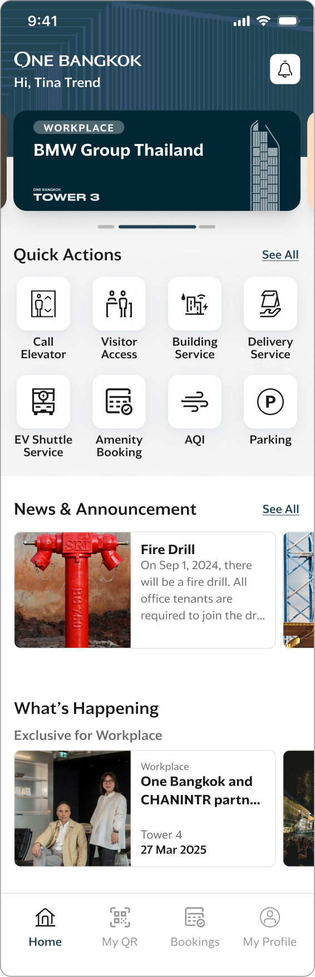

1.1 Call Elevator
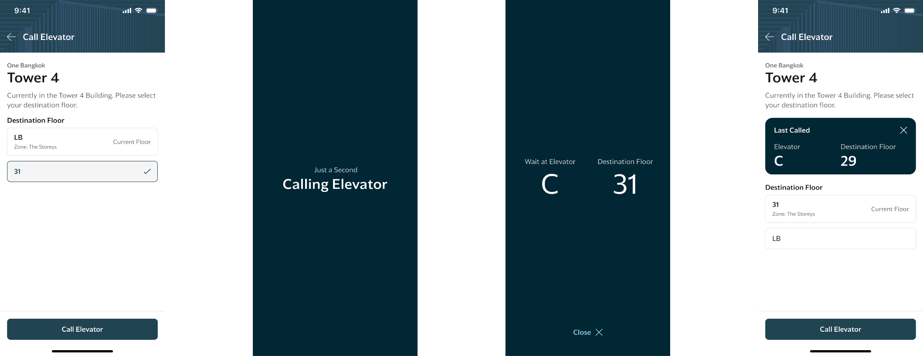

1.2 Visitor Access
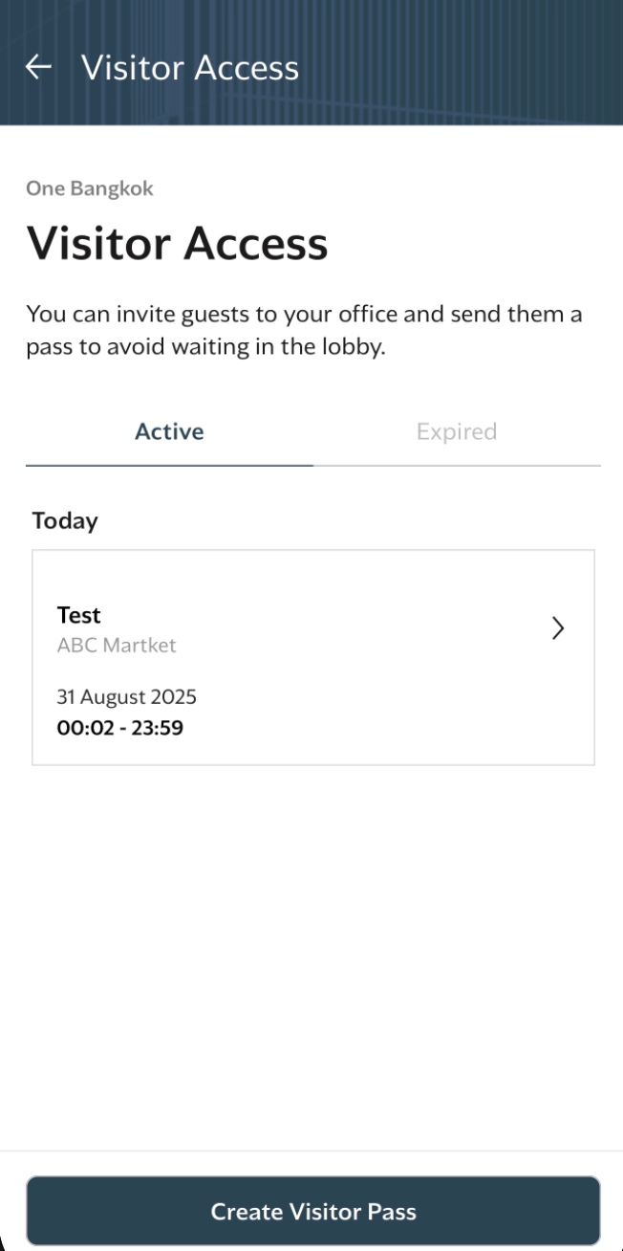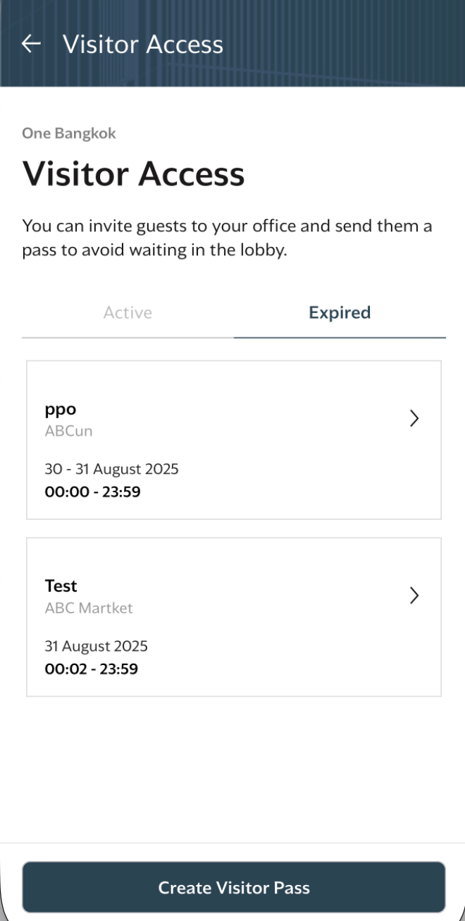

1.2.1 Create visitor access
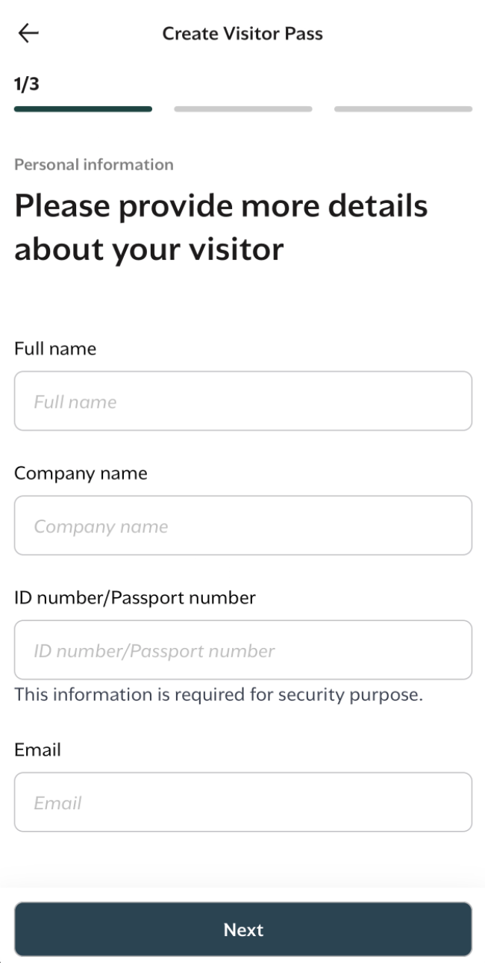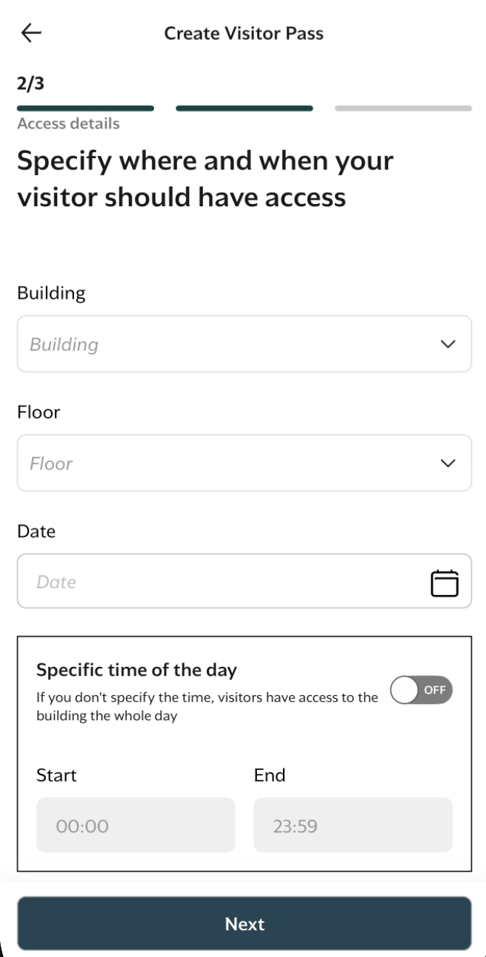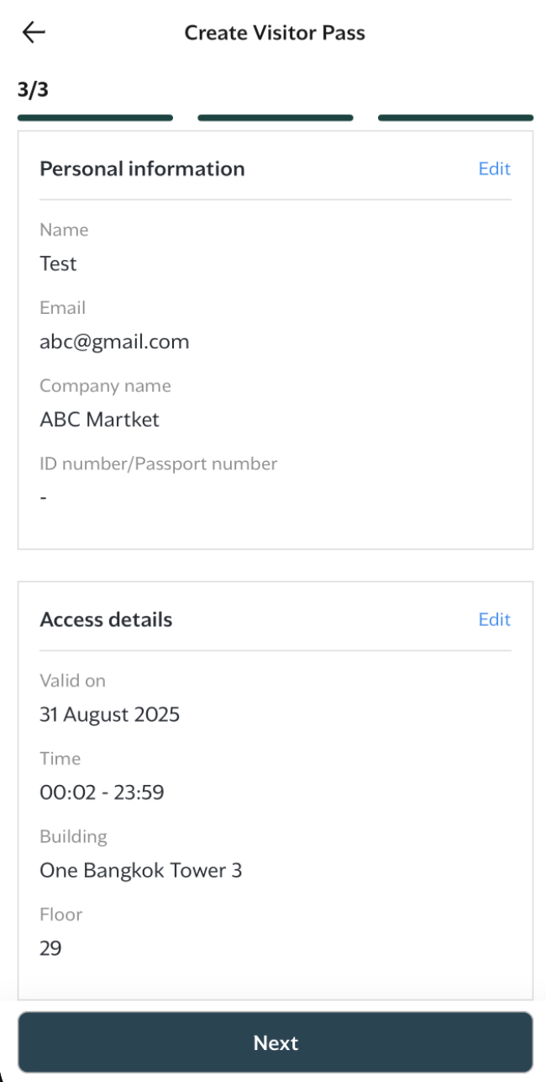

1.3 Building Services
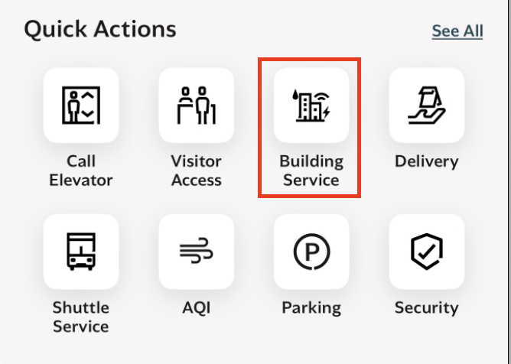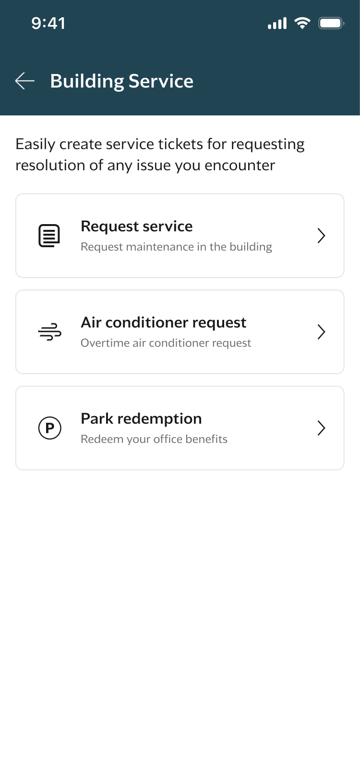

1.3.1 Request service

